School of Games and Creative Technology  BSc (Hons) Computer Science  BSc (Hons) Creative Computing | 

Introduce to Artificial Intelligence
LAB 1 - Chapter 1 Getting Started with Python

Task 1

https://www.jetbrains.com/guide/python/tutorials/getting-started-pycharm/installation-and-setup/

Finding and downloading
Download PyCharm by clicking the download button.
Installing
These instructions differ depending on your operating system.
On the first launch of PyCharm Professional, you’ll be asked to log into your JetBrains account
Welcome Screen
When you open PyCharm for the first time, you are presented with the Welcome Screen.
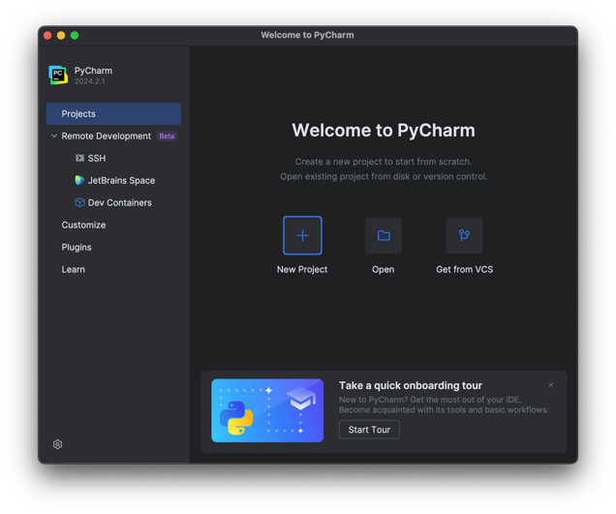
From PyCharm's Welcome Screen, there are four main sections you can explore.
On the Learn PyCharm tab you can use the links to jump to documentation pages and other resources, and you can also enroll in the interactive Feature Trainer which is designed to quickly teach you some productivity boosters in PyCharm.
The Plugins tab lets you install some additional plugins like custom themes or keymaps if you are coming from other editors/IDEs.
Installing Keymaps makes your migration from other editors easier and painless. To search, just start typing “keymaps”, for example, and PyCharm will list available keymaps for popular editors. You can find the one that suits you best and click it to install it.
The Customize section lets you tweak some of the most commonly used settings. For example, we can change our theme from Darcula to IntelliJ Light. You can also sync with the OS if you prefer. If you have installed any keymap or themes plugin you would need to switch it here as well.
Finally, on the Projects tab, you can create, open, or clone projects to start working with.

Starting a Project
Now, back to where we left off on the Welcome Screen and the “Projects” tab. If you’ve already worked on a project, the welcome screen will look a bit different. It will have a list of your recent projects in the center but the options will stay the same.
There are three available options on this screen.

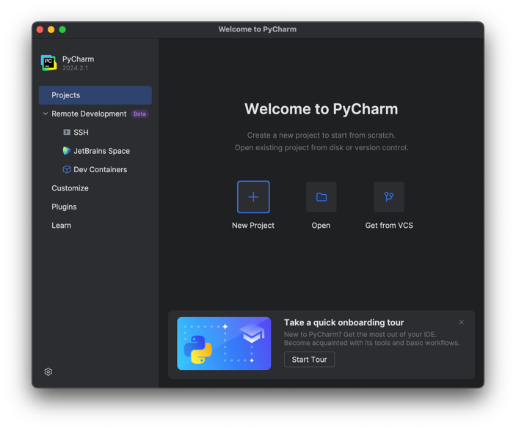
First, you can get an existing project from version control like GitHub, for example. You could then paste a repository URL in and click Clone.
Secondly, you can open a project stored on your machine by navigating to your local drive and finding a project you want to work on. Then, select it and click Open.
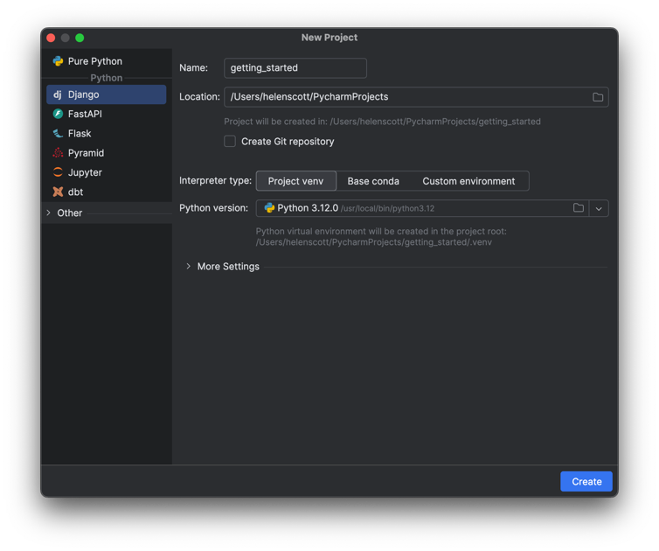
In Python projects, it’s a best practice to do your work by creating a virtual environment. Each project then acts like it has its own Python. If you install some packages in one project, it won’t break another project.
PyCharm takes care of this part by creating and activating a virtual environment for your new project. Back to our New Project screen, we have a section called Python Interpreter: New Virtualenv environment. In our case, we are going to create a new one using virtualenv, but as you can see here PyCharm also supports PipEnv and Conda out of the box.
We already have Python 3.10 installed as my default Python. PyCharm detected it, so we can click Create.
PyCharm will now create a new Django project for you as well as creating and activating a virtual environment, downloading all the required dependencies, generating an empty Django project with configuration files, creating run and debug configurations, and more.
If you close this project, you go back to the PyCharm Welcome Screen where you can see that the Projects tab has changed slightly. Now you see your recent projects, and this list will grow as you have more projects.

Task 2

In this exercise, you need to answer the following questions.
1. Among the following options, which is not a characteristic of the Python language?
A. Easy to learn
B. Open source
C. Procedural
D. Portability
2. Among the following statements about Python, which is incorrect?
A. Python was developed from ABC
B. Python source code needs to be compiled and linked to generate an executable file
C. Python is open source and can be ported to many platforms
D. Python is a high-level computer language
3. Of the following fields, which is not a major application area of Python?
A. Web application development
B. Scientific computing
C. Operating system management
D. 3D game development

4. Write a program that requires the input of two integers, calculates the sum of the two numbers, and then outputs the result.

5. Write a program that requires the input of the three sides of a triangle (assuming that the given three sides meet the conditions for forming a triangle: the sum of any two sides is greater than the third side), calculates the area of the triangle, and then outputs the result.

